Create database
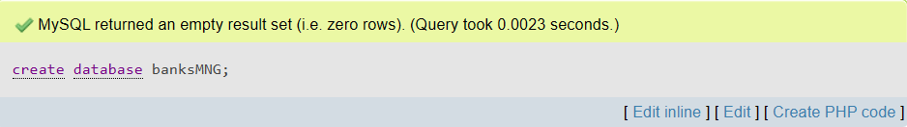
Consider the following
- Customer (c_id, c_name, street, city)
- Account (ac_no, branch_name, balance)
- Branch (branch_name, branch_city, assets)
- Depositor (c_name, ac_no)
- Borrower (c_name, loan_no)
- Loan (loan_no, branch_name, amount)
- Employee (emp_name, branch_name, salary)
Create table Customer
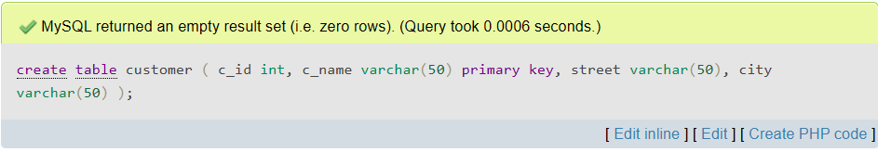
Create table Account
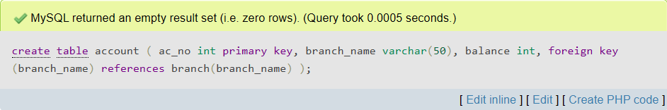

Create table Branch
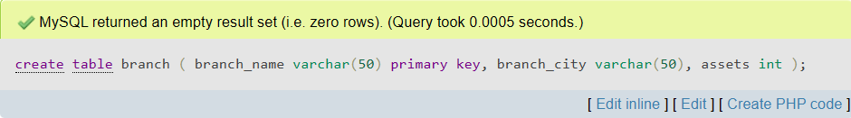
Create table Depositor
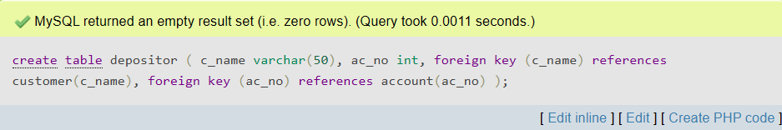
Create table Borrower
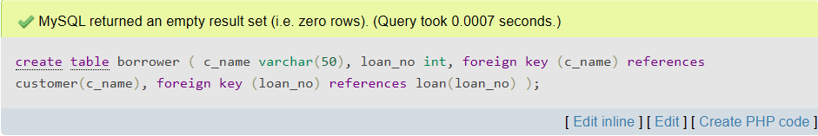
Create table Loan
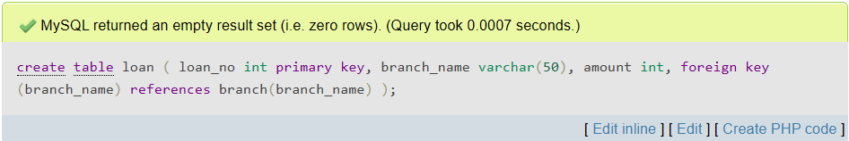

Create table Employee
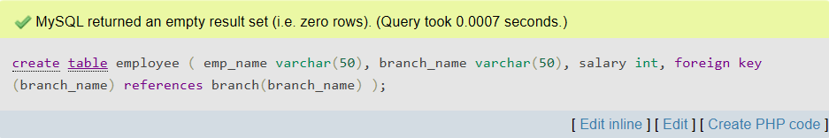

Describe Customer
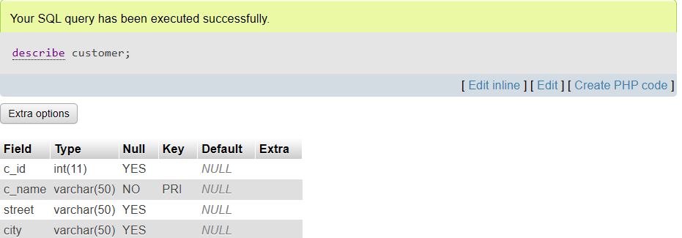
Insert Customer
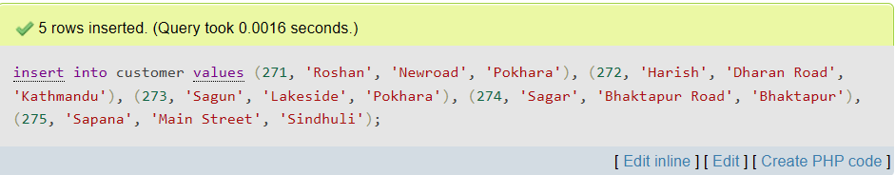
Display Customer
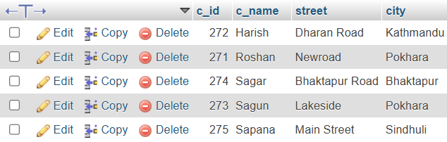

Describe Account
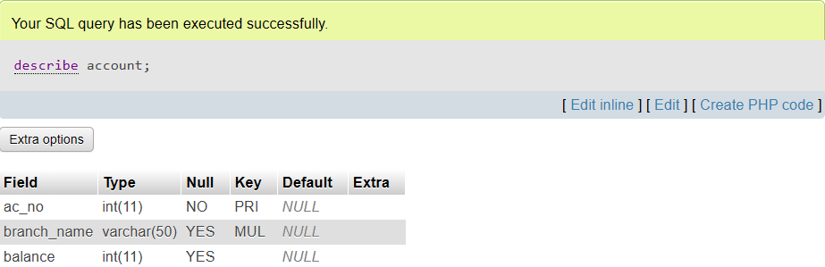
Insert Account
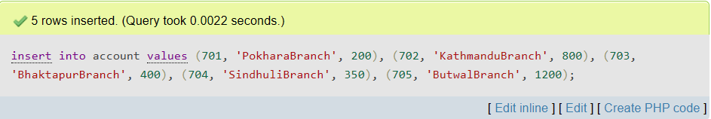
Display Account
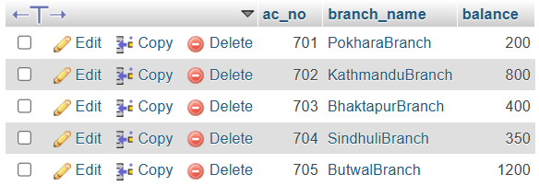

Describe branch
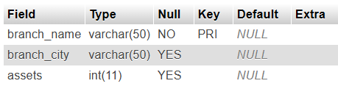
Insert Branch
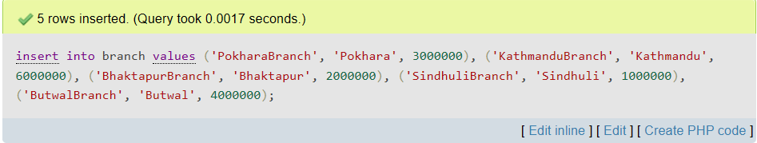
Display Branch
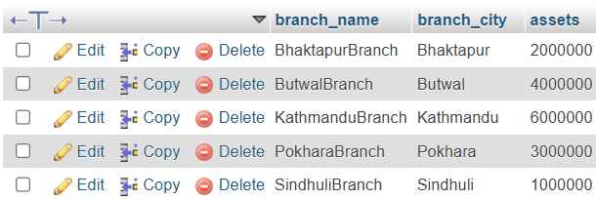

Describe Loan
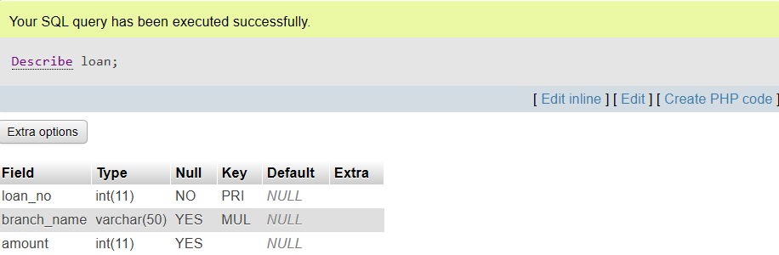
Insert Loan
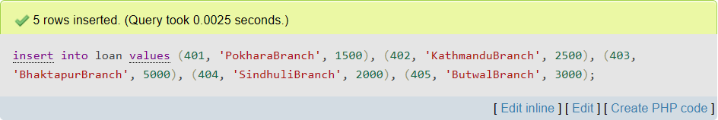
Display Loan
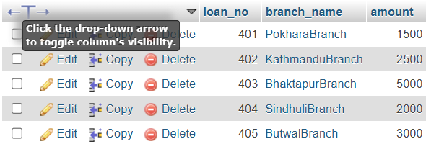

Describe Depositor
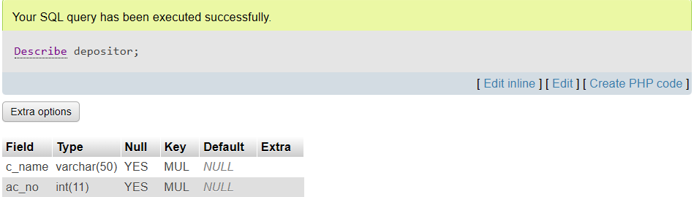
Insert Depositor
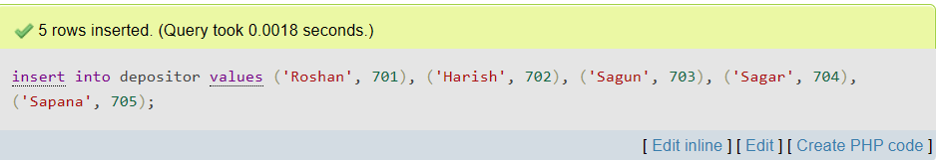
Display Depositor
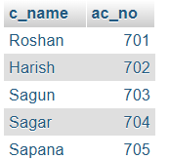

Describe Borrower
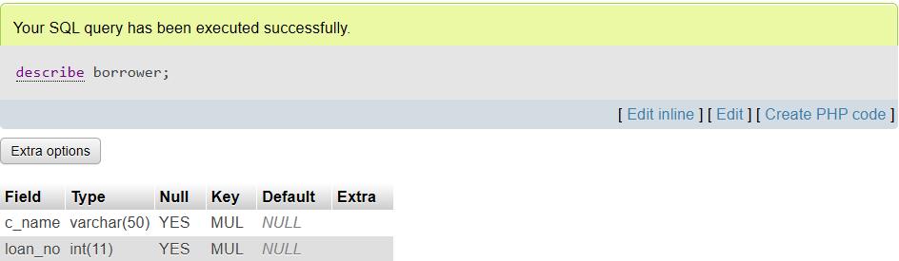
Insert Borrower
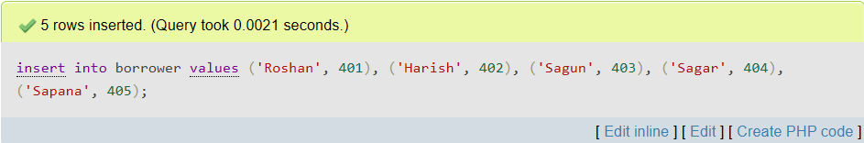
Display Borrower
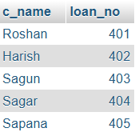

Describe Employee
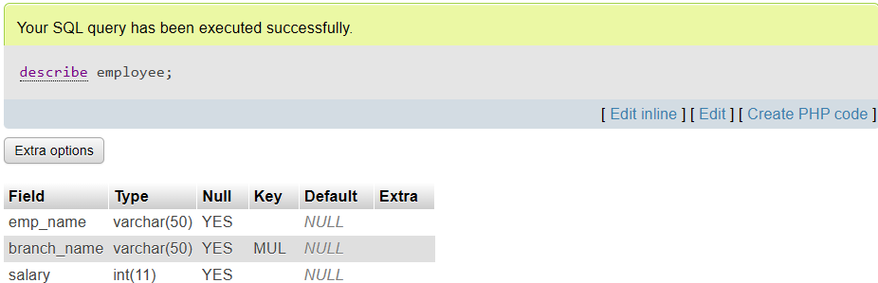
Insert Employee
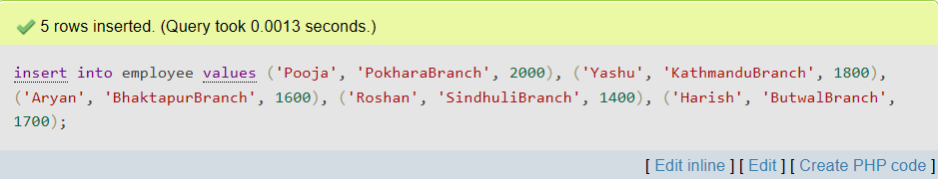
Display Employee
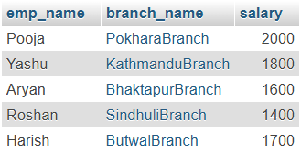

- Write sql.
1. Find all account whose balance is smaller than 500.
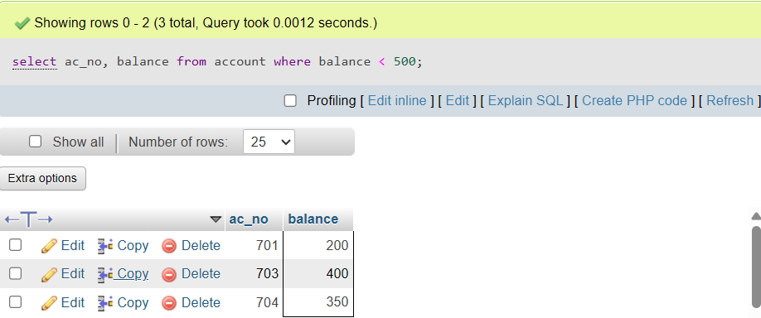
2. Find all name of customer whose city is from pokhara.
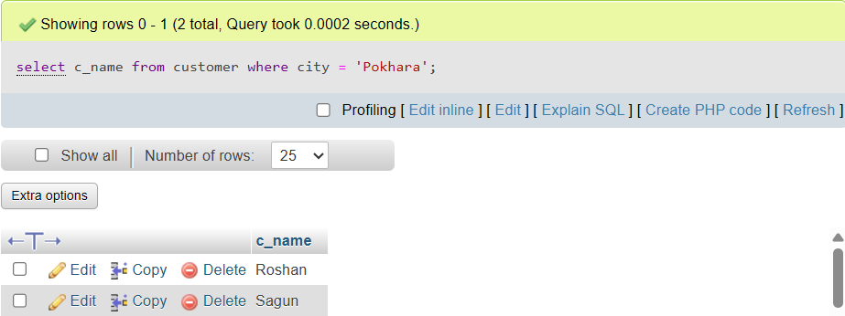
3. Find all employee whose salary is greater than 1500 and working branch is not Kathmandu.
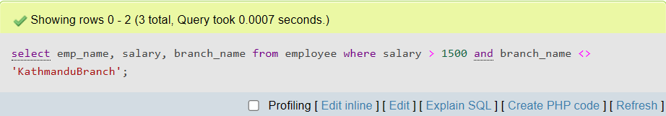

4. Calculate the average salary of all employee and show average salary as “avg_salary”
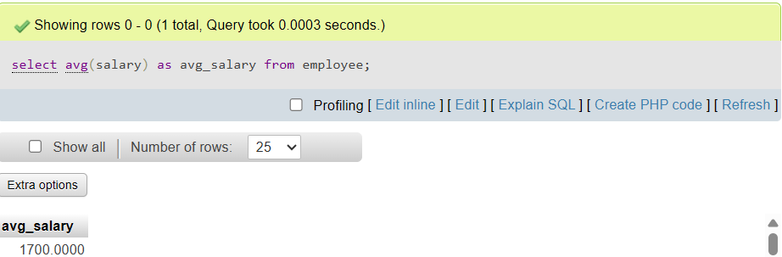
5. Calculate the number of customer for each account.

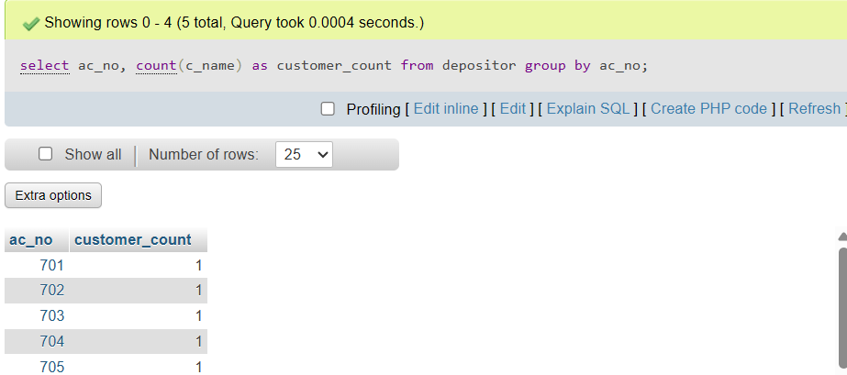
6. Show all account no, branch_name and corresponding branch_city.
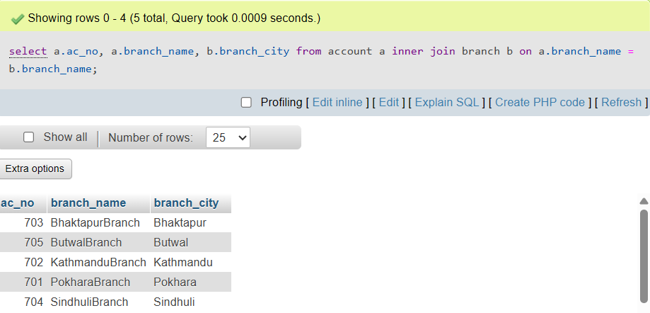
7. Find the name of all branches from loan relation and don’t display duplicates.
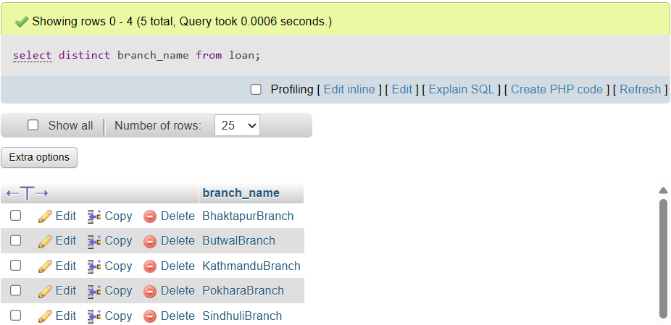
8. Find account no and balance for all accounts from sindhuli where balance is $400 or less.
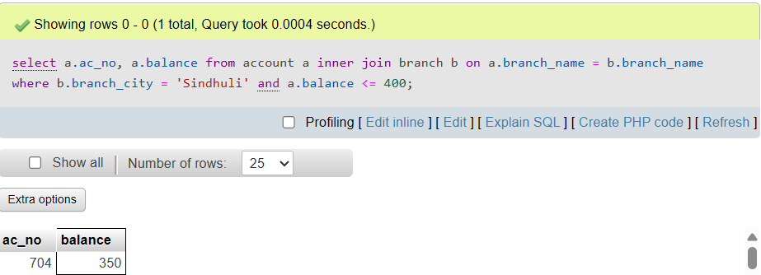
9. Find the name of all branches with assets between 1 and 4 million.
